Corey Gaspar

2/15/2025

**Project 3: Corner Grocer Program Documentation**

For Project 3, I was tasked to create a program for Corner Grocer that analyzes text records collected throughout a given day. These records are listed in chronological order from opening to closing time. The program reads from an external text file named *InputFile.txt*. This text file contains a list of all items purchased in a given day. The user can then search for items in this list, display the frequencies of each item, generate a histogram for the frequency of each item, and even backup the text data into a file called frequency.dat.

In this program, I have created three files, two of which are .cpp files. The main.cpp file is used to handle user interaction with the input menu. ItemTracker.h and ItemTracker.cpp are responsible for reading and writing item frequencies. My code takes on an object-oriented approach through the reuse of my ItemTracker class throughout the program.

When the program starts, a menu is printed out to the user containing 4 different options they can choose from. Not only is my menu functional, but I wanted to give it some design, so I added lines using equal symbols. In this menu, the user can search for an item in the list, display all item frequencies, display a histogram of item frequencies, and exit the program.

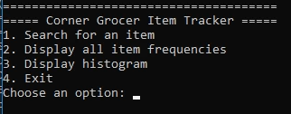

If the user chooses Option 1, they will be able to search for an item. If the item is in the list, it will print out the item name and the frequency of the item. If the item is not in the list, it will print out an error and have the user search again. I also made it so that the user input automatically gets converted to lowercase.

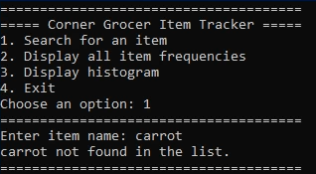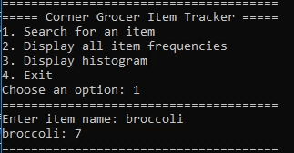

If the user chooses Option 2, the program will print out the InputFile.txt list with the item name and the frequency of the item. If the user chooses Option 3, the same list will be printed out but instead of it printing a number, it prints out a histogram version of the frequency. Option 4 lets the user exit the program. Everything from the list gets backed up to frequency.dat.

